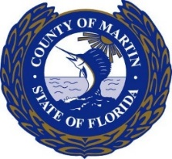

BID TABULATION

RFB2024-3586
GRINDER STATION INSTALLATION & SEPTIC CONVERSION (RE-BID)
DATE ADVERTISED: MARCH 29, 2024
BID DUE DATE: MAY 1, 2024 @ 2:30 PM

MEEKS PLUMBING, INC. | Bid Amount | $1,450,500.00
BAKER UNDERGROUND CONTRACTORS, LLC. | Bid Amount | $1,501,440.00
THE LAZARUS GROUP, INC. | Bid Amount | $1,504,313.00
JAMIE UNDERGROUND, INC. | Bid Amount | $1,872,500.00

DEMANDSTAR STATISTICS:

NUMBER OF BIDDERS: 4
NUMBER OF PLANHOLDERS: 29
NUMBER OF SUPPLIERS NOTIFIED: 1,175

This is a preliminary summary of the bids as they were opened and announced at the bid opening. Bid prices have not been verified and are subject to change in the event mathematical errors are discovered during bid review. Other information contained in this summary is also subject to review.

This document may be reproduced upon request in an alternative format by contacting the County ADA Coordinator (772) 320-3131, the County Administration Office (772) 288-5400, Florida Relay 711, or by completing our accessibility feedback form at www.martin.fl.us/accessibility-feedback

